**REPORT ON “THE CHASE’’ GAME**

The game is mainly run in the terminal by running the python file in the directory via command line:

***python .\game.py***

Running this command displays a menu interface to choose from, to either play the game or get information on how to play the game as well as to exit the game.

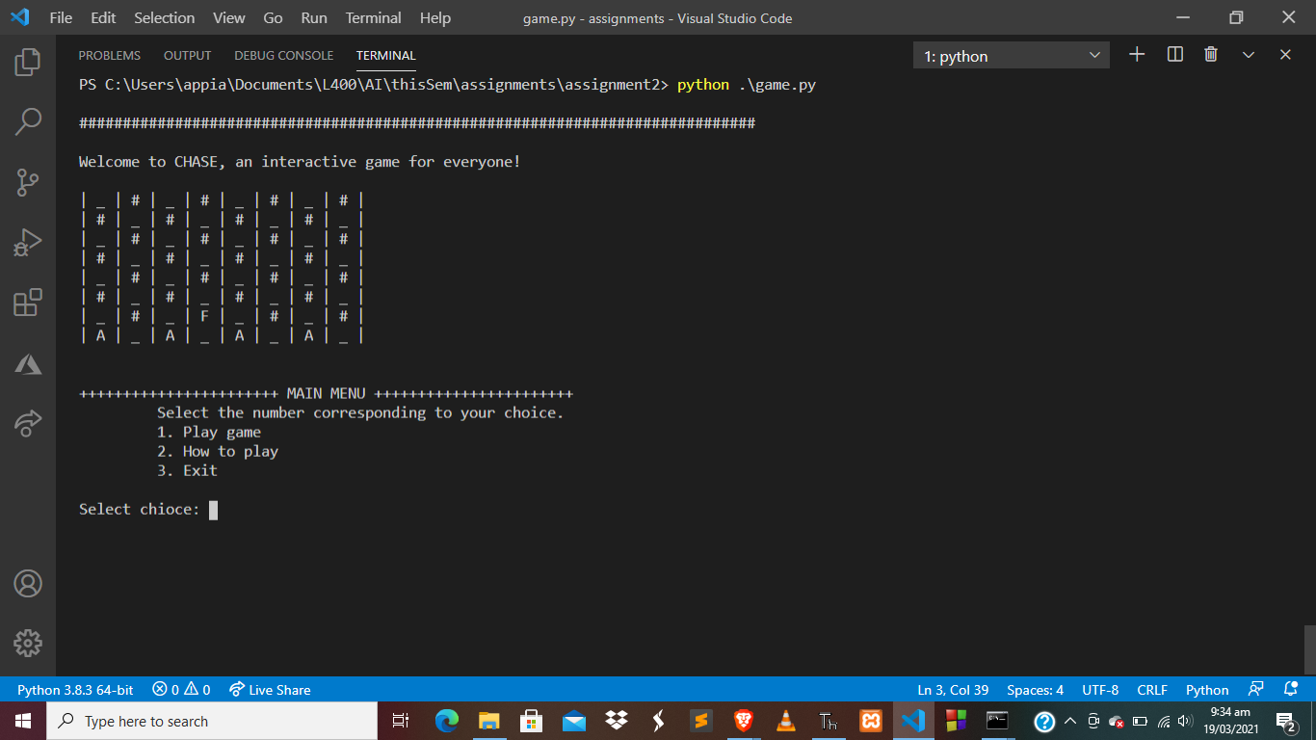

**Functions**

Selecting **Choice** **1** from the main menu

* Initializes the game play
* Play Mode:
* Play as Fugitive: Enter “F”
* Play as Agent: Enter “A”

Movements

* Move in forward-Left direction: fl
* Move in forward-Right direction: fr
* Move in backward-Left direction: bl
* Move in backward-Right direction: br

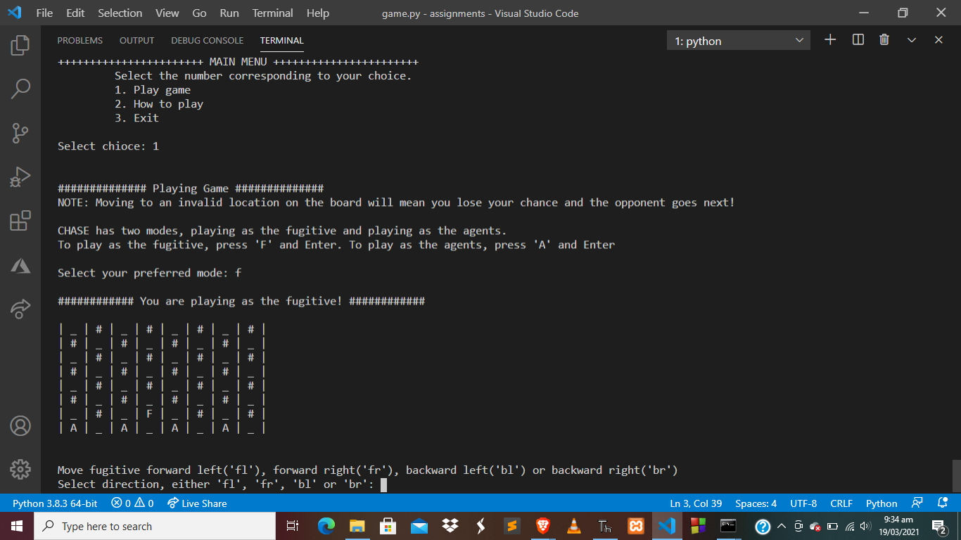

**Win /Lose**

